Summer CREATE Letter Template

Dear Parents,

The Classical Thistle is a website devoted to exploring and promoting classical Christian education in a 21st century context. You can also find The Classical Thistle on Facebook, Twitter, and Instagram. If you visit the website (www.theclassicalthistle.com), you will find over eight years of published content on classical Christian education aimed at training and encouraging teachers and parents in this important work.

As we enter into the summer, we encourage you to read one article in particular by Sara Osborne, a frequent contributor to the site. Her article, “Four Ways to Grow Your Classically Educated Child This Summer,” has some excellent advice for parents going into the summer months. In this article, Sara recommends four ways to keep your child learning over the summer months: read, travel, explore, and create.

As a way of encouraging student growth by putting these things into practice, we at (SCHOOL NAME) have decided to sponsor a “Create!” contest. Students will create a project based on a book, an exploration, or a journey (the first three points in Sara’s article). Students will then create (fourth point) as a result of reading, traveling, or exploring. Our hope is to display these projects somewhere on campus during the first weeks of the fall semester and award small prizes for the top projects in each age division.

If you have questions about the project, you can contact (School Representative contact info). If you want to learn more about The Classical Thistle, you can contact its founder, Kyle Rapinchuk, at kyle@theclassicalthistle.com.

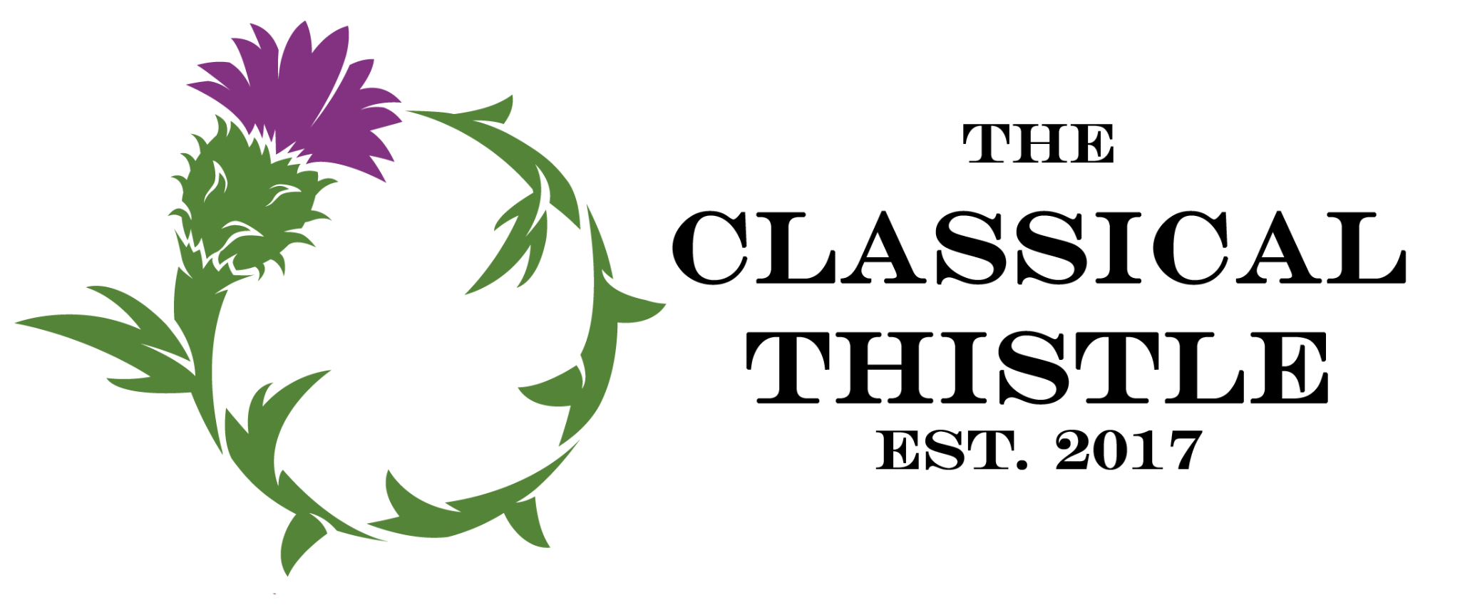
Have a happy and learning filled summer!

CREATE! Project Guidelines

In response to a book, an exploration, or a journey encountered throughout the summer, students are invited to create an original project which exhibits creativity and demonstrates educational growth. A brief (one paragraph) description of the book, exploration, or journey which led to the project should be included with each entry.

Projects will be evaluated in the following areas:
- Creativity
- Organization
- Clarity of message(s)
- Demonstration of educational growth

Students will be categorized according to the grade they are entering for the ______ school year.

Projects will be judged according to the following grade divisions:
- Rising K-2nd graders
- Rising 3rd-6th graders
- Rising 7th-9th graders
- Rising 10-12th graders

*Projects should be completed and submitted to (SCHOOL CONTACT) by (DATE).

Schools have permission to utilize the text of this letter and the CREATE! Contest guidelines. Please give credit to The Classical Thistle if you do choose to utilize the project, and please encourage your families to explore our website and consider attending our conferences.

